Assignment-2.1
Hall.No:2303A51862
Batch No:13
Name: K.Lokesh
Task 1
Statistical Summary for Survey Data
- Scenario:
You are a data analyst intern working with survey responses stored as numerical lists.
- Task:
Use Google Gemini in Colab to generate a Python function that reads a list of numbers and calculates the mean, minimum, and maximum values.
- Expected Output:
- Correct Python function
- Output shown in Colab
- Screenshot of Gemini prompt and result
Prompt
Generate a Python function that reads a list of numbers and calculates the mean, minimum, and maximum values.
Code
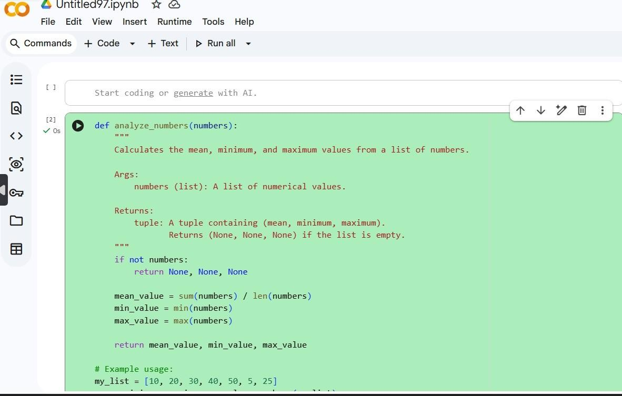

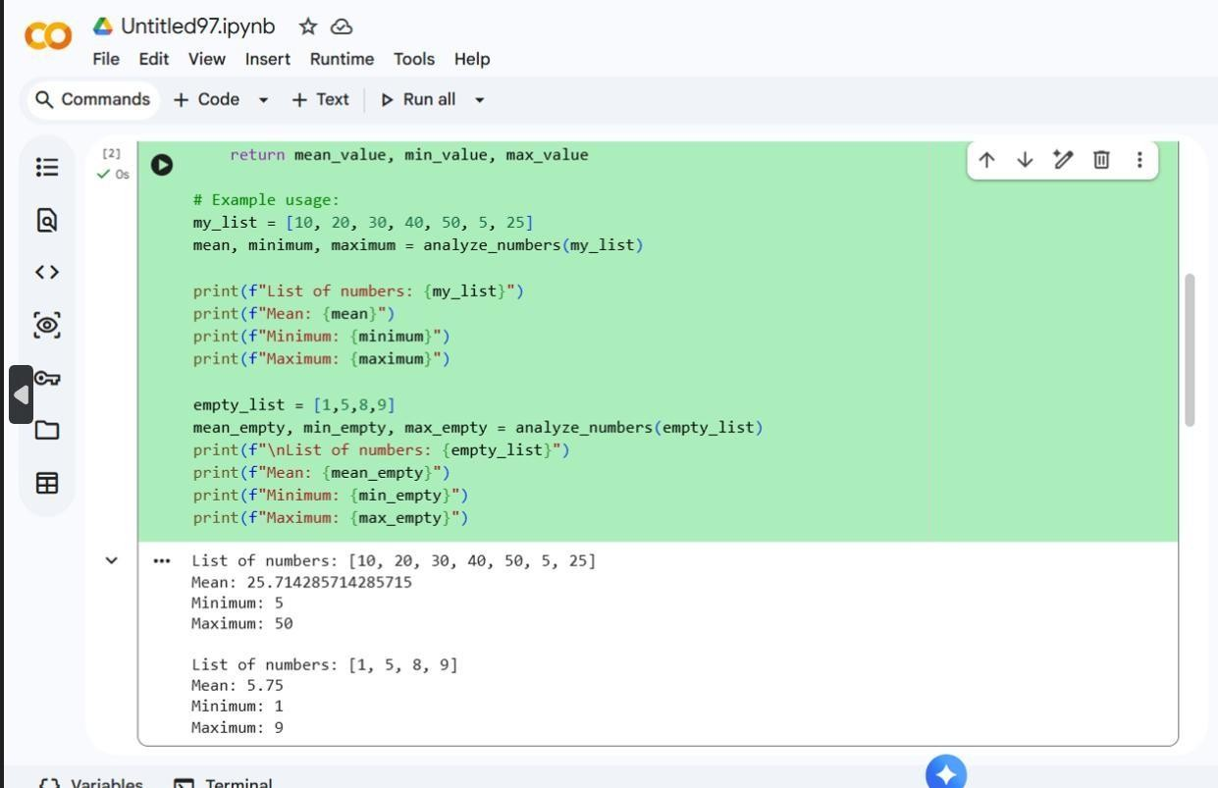

Output:

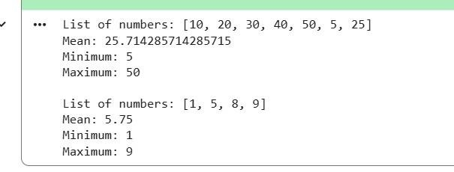

Justification:
This task demonstrates how AI tools can assist in quickly generating reliable utility functions for basic data analysis. Survey datasets often require immediate preprocessing to understand value ranges and central tendencies. By using an AI-generated Python function, the analyst is able to obtain accurate mean, minimum, and maximum values with minimal effort. Running the code in Google Colab ensures correctness through instant execution and visible output. This task highlights how AI support improves productivity while maintaining correctness in simple yet essential analytical computations.

Task-2
Armstrong Number – AI Comparison
- Scenario:
You are evaluating AI tools for numeric validation logic.
- Task:
Generate an Armstrong number checker using Gemini and GitHub Copilot. Compare their outputs, logic style, and clarity.
- Expected Output:
- Side-by-side comparison table
- Screenshots of prompts and generated code Using Gemini Prompt:
Write a Python program to check whether a given number is an Armstrong number.
Code:
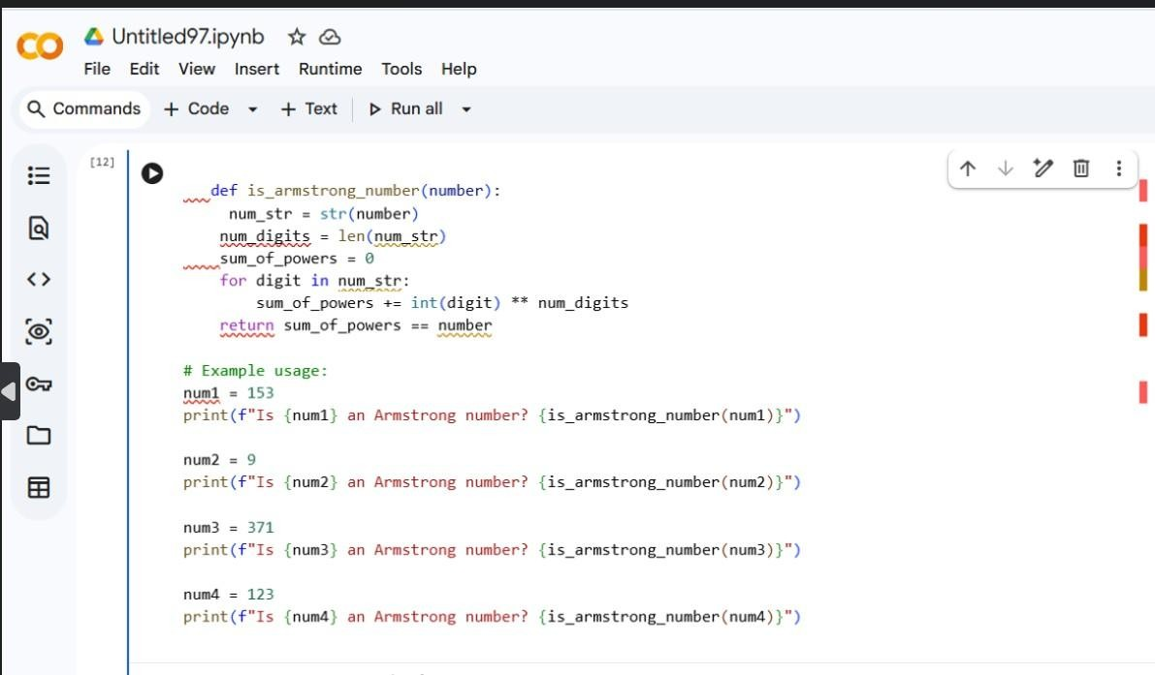

Output:
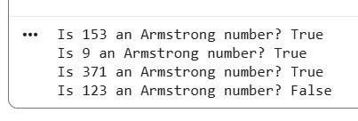
Using Github Copilot:
Prompt:
Generate an Armstrong number checker Code:
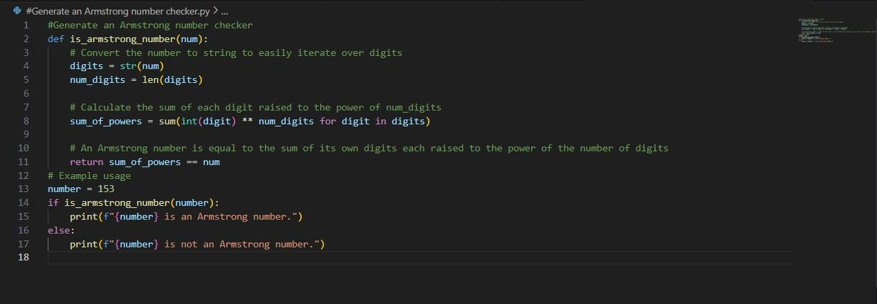
Output:
Logic Style Comparison:
Aspect | Google Gemini | Github Copilot
Code Length | Short and concise | slightly longer
Logic Style | pythonic | Traditional
Readability | clear and compact | Step by step
Beginner friendly | moderate | High
Output Accuracy | correct | Correct

Justification:
This task focuses on understanding how different AI coding assistants approach the same computational problem. By generating Armstrong number validation logic using both Google Gemini and GitHub Copilot, variations in implementation style, structure, and readability become evident. While both solutions achieve correct results, the differences help evaluate which tool better aligns with developer preferences and coding standards. This task justifies the need to compare AI tools before adopting them in real projects, as logic clarity and maintainability are as important as correctness.
Task-3
Leap Year Validation Using Cursor AI
- Scenario:
You are validating a calendar module for a backend system.
- Task:
Use Cursor AI to generate a Python program that checks whether a given year is a leap year.
Use at least two different prompts and observe changes in code.
- Expected Output:
- Two versions of code
- Sample inputs/outputs
- Brief comparison
Prompt1:
Write a Python program to check whether a given year is a leap year.
Code:
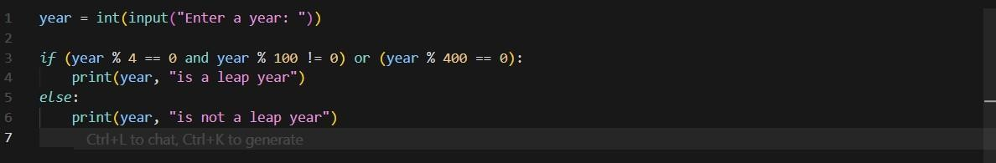
Output:
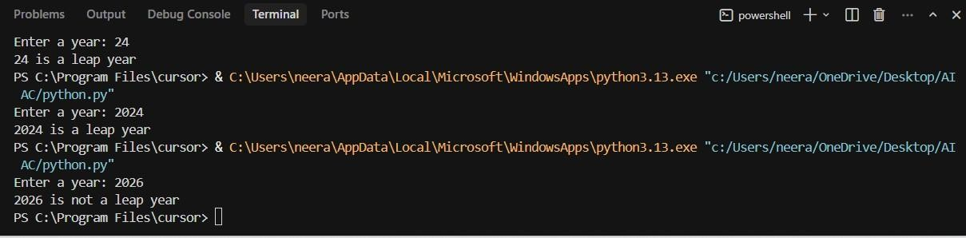
Prompt2:
Create a Python function that returns true if a year is a leap year, otherwise false.
Code:
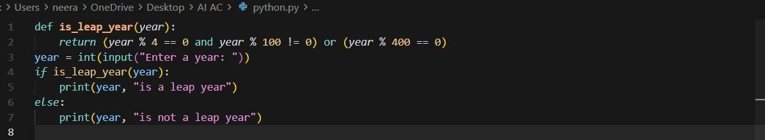
Output:
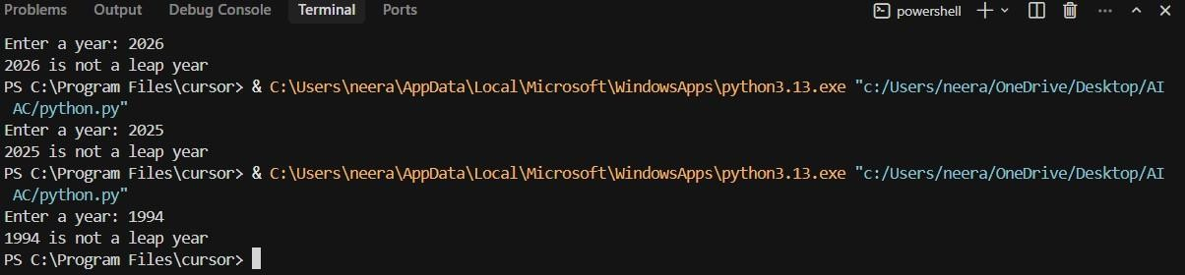
Justification:
This task emphasizes the role of prompt specificity in AI-generated code quality. Using two different prompts with Cursor AI resulted in distinct implementations of leap year validation logic. The variation between outputs illustrates how clearer and more detailed prompts lead to more accurate and reusable solutions. This is especially important in backend systems where incorrect date logic can cause serious errors. The task validates that developers must actively refine prompts to obtain reliable AI-assisted solutions rather than relying on generic instructions.

Task-4
Student Logic + AI Refactoring (Odd/Even Sum)
- Scenario:
Company policy requires developers to write logic before using AI.
- Task:
Write a Python program that calculates the sum of odd and even numbers in a tuple, then refactor it using any AI tool.
- Expected Output:
- Original code
- Refactored code
- Explanation of improvements
Prompt:
Write a Python program that calculates the sum of odd and even numbers in a tuple.
Code:
1)Original code:
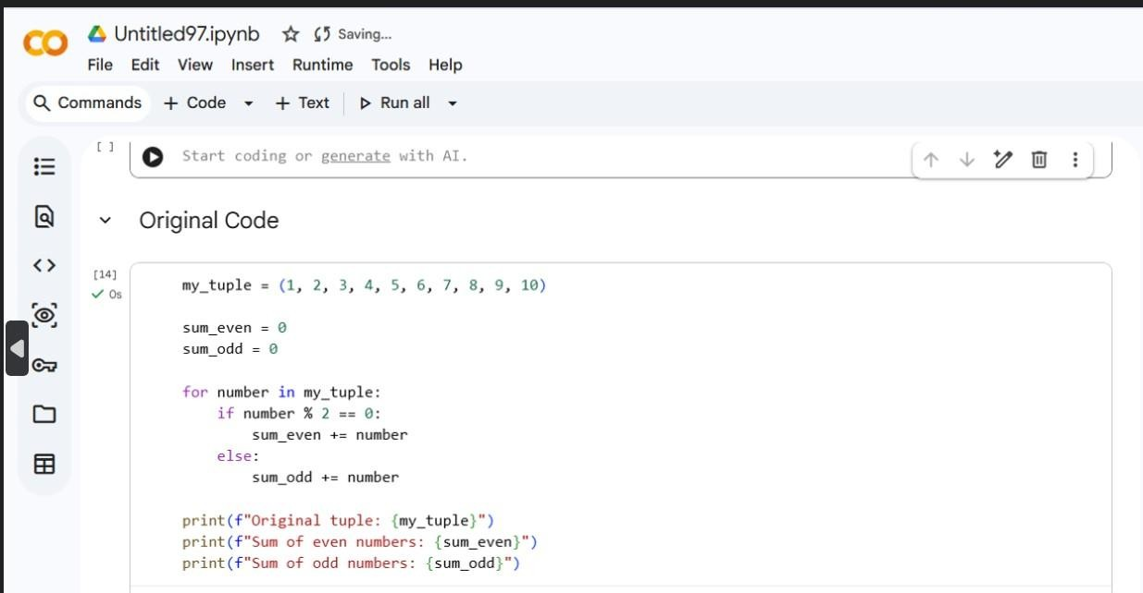
Output:
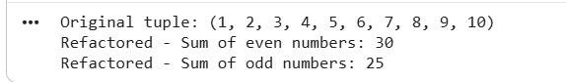
2) Refactored code Code:
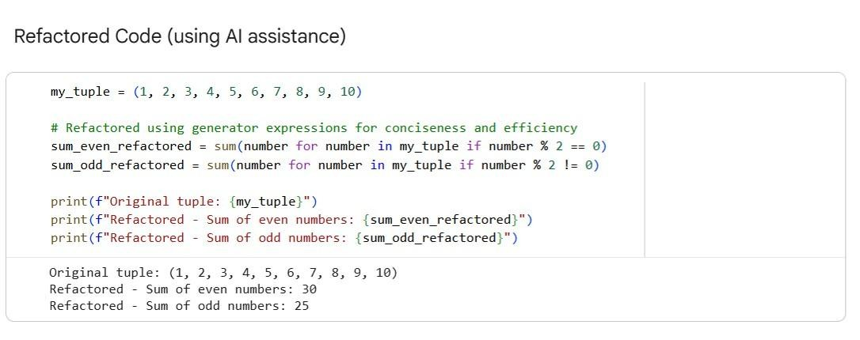
Output:
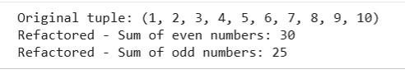
Explanation of Improvements
The refactored code leverages Python’s built-in sum() function along with generator expressions. This approach offers several benefits.
First, conciseness: the refactored code significantly reduces the number of lines, making the logic more compact and clean.
Second, readability: for developers familiar with Pythonic constructs, generator expressions clearly express the intent of the code, such as calculating the sum of numbers based on a condition, which makes the program easier to understand at a glance.
Third, efficiency: built-in functions like sum() are implemented in highly optimized C code, making them faster than explicit for loops for larger datasets. Generator expressions also improve memory efficiency by producing values one at a time instead of creating intermediate lists.
Finally, functional programming style: the refactored approach follows a functional style, which generally results in cleaner, more maintainable, and less error-prone code.
Justification:
This task assesses Copilot’s ability to generate different logical strategies for the same problem. Comparing basic and optimized approaches highlights differences in execution flow, time complexity, and performance, helping determine when each approach is appropriate.

